Names:

Place Value Chart

Constellation Name:

Star Name:

Distance from Earth:

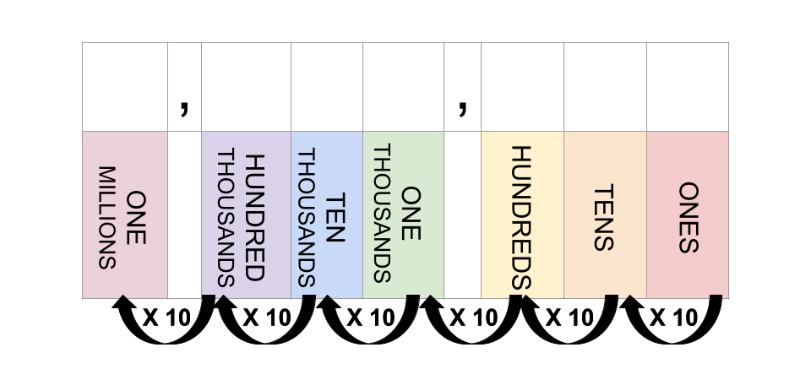

Star Name:

Distance from Earth:



* What digit(s) do the two numbers share?
* What place values are they in?
* How many times greater is the digit in one place value versus the other?